COGNIFYZ TECHNOLOGIES INTERNSHIP REPORT
Title: Mutual Funds Data Analysis

Cover Page
Name: Ragelagunta Venkatadri
Internship Role: Business Analyst Intern
Organization: Cognifyz Technologies
Project Title: Mutual Funds Data Analysis
Tools Used: MySQL, Excel, Power BI
Duration: 15-03-2026 to 15-04-2026

Introduction
This project focuses on analysing a Mutual Funds dataset to understand investor behaviour, preferences, and financial decision-making patterns. The analysis was performed using data analytics and visualization tools to extract insights that can aid in investment decision-making.

Objective
- Understand dataset structure
- Analyse investor demographics
- Identify investment preferences
- Generate insights for financial decision-making

Workflow
- Data Collection
- Data Import into MySQL
- Data Understanding
4. Data Analysis
5. Visualization using charts
6. Insight Generation
Report Preparation

Level 1: Beginner
Task 1: Data Overview
- Objective: Understand dataset structure
- Details: I import the mutual funds data into MySQL workbench and about total records I wrote the code I have known I am giving code below whatever code I have written as well as screen short also
select * from dataset;
desc dataset;
show columns from dataset;
select count(gender) as total_rows from dataset;
select age,count(age) as total_count from dataset group by age;select * from dataset;
select age,Mutual_Funds,Equity_Market,Debentures,Government_Bonds,Fixed_Deposits from dataset;
select max(age) as max_age,min(age) as min_age,avg(age) as avg_age from dataset;
SELECT MAX(Mutual_Funds) AS max_funds,MIN(Mutual_Funds) AS min_funds,AVG(Mutual_Funds) AS avg_funds,
MAX(Equity_Market) AS max_Equity,MIN(Equity_Market) AS min_marker,AVG(Equity_Market) AS avg_market,
MAX(Debentures) AS max_Debentures,min(Debentures) as min_Debentures,avg(Debentures) as avg_Debentures,
max(Government_Bonds) as max_bonds,min(Government_Bonds) as min_bonds,avg(Government_Bonds) as avg_bonds,
max(Fixed_Deposits) as max_deposit,min(Fixed_Deposits) as min_deposite,avg(Fixed_Deposits) as avg_deposits
from dataset;
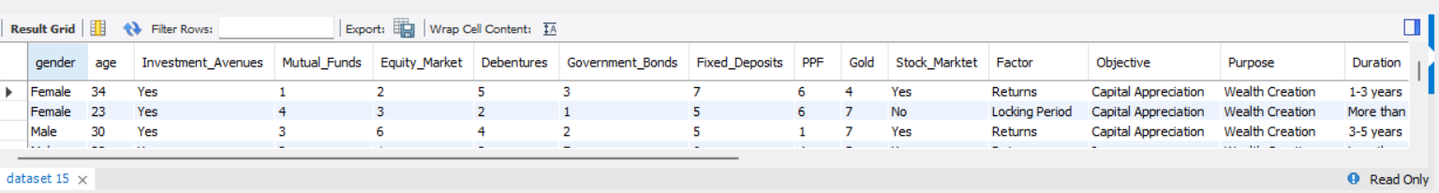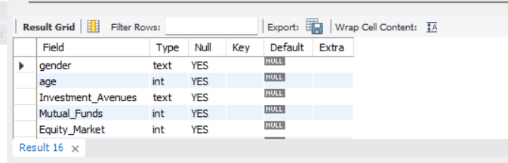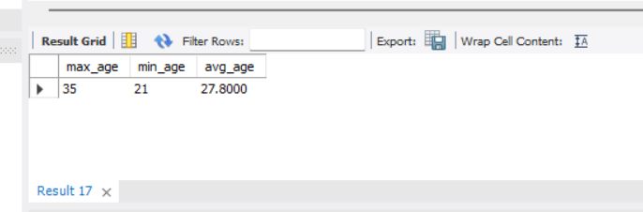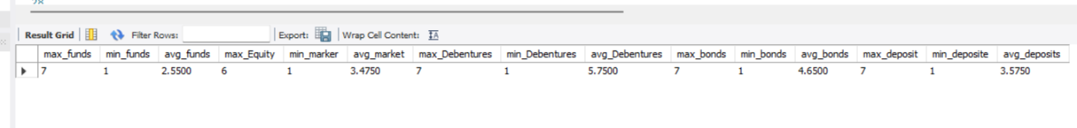
select avg(age) as avg_age,avg(Mutual_Funds) as avg_funds,avg(Equity_Market) as avg_market,avg(Debentures)
as avg_Debentures,avg(Government_Bonds) as avg_bonds,avg(Fixed_Deposits) as avg_deposits,avg(gold)
as avg_gold from dataset;
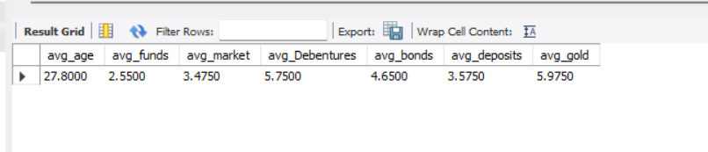
- Insight: finally in the task 1 I have found the maximum and minimum and average and Dataset structure, column names, and total records based on give mutual dataset
Task 2: Gender Distribution
- Objective: Visualize gender distribution
- Details: in this task 2 based on gender column I have find the total count group wise using group by class and average persenttage also you can see desending wise also and Visualization like pic chart and bar chat I have created in poer bi tool. See below the code and screen shorts
select * from dataset;
select gender,count(gender) as total_count from dataset group by gender order by total_count;
select gender,count(gender) as total_count from dataset group by gender order by total_count desc;
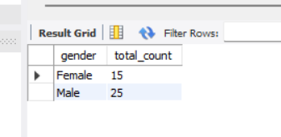
SELECT gender,COUNT(gender) AS total_count,ROUND(COUNT(gender) * 100.0 / (SELECT COUNT(gender)
FROM dataset), 2) AS total_Pstg from dataset GROUP BY gender ORDER BY total_count DESC;
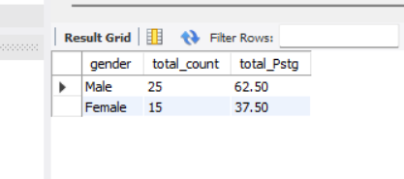

- Visualization: Pie chart and bar chart I created in Power BI tool
- Insight: finally in this task I have known male total is 25 and female total is 15 and total average 62.50 and 37.50
Level 2: Intermediate
Task 3: Descriptive Statistics
- Objective: Calculate basic statistics for numerical columns
- Details: I have analysed based give numerical columns like age,Mutual_Funds,Equity_Market,Debentures,Government_Bonds,Fixed_Deposits,PPF,gold and I calculate the numerical calamus with mean median and mode and standard deviation I am giving code and pics below
select * from dataset;
select age,Mutual_Funds,Equity_Market,Debentures,Government_Bonds,Fixed_Deposits PPF,gold from dataset;
select avg(age) as avg_age,stddev(age) as atd_age from dataset;
select avg(Mutual_Funds) as mean_funds,stddev(Mutual_Funds) as std_funds from dataset;
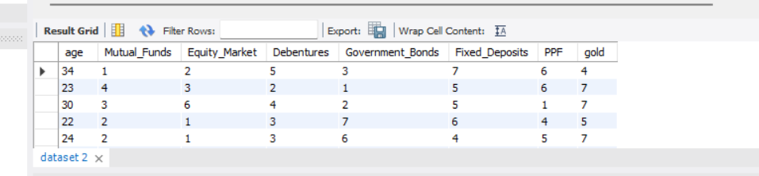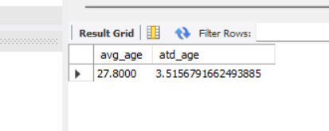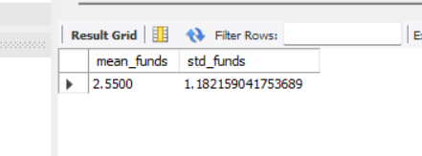
select avg(age) as avg_age,stddev(age) as std_age,
avg(Mutual_Funds) as avg_funds,stddev(Mutual_Funds) as std_funds,
avg(Equity_Market) as avg_equity,stddev(Equity_Market) as std_quity,
avg(Debentures) as avg_debts,stddev(Debentures) as std_bdts,
avg(Government_Bonds) as avg_bonds,stddev(Government_Bonds) as std_bonds,
avg(Fixed_Deposits) as avg_deposits,stddev(Fixed_Deposits) as std_deposits,
avg(PPF) as avg_ppf,stddev(PPF) as std_ppf,
avg(gold) as avg_gold,stddev(gold) as std_gold from dataset;
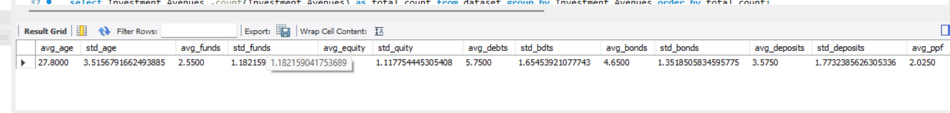
- Insight: finally in this task Statistical measures helped understand the distribution and variation in investment data.
Task 4: Most Preferred Investment Avenue
- Objective: Identify the most preferred investment avenue
- Details: Analyzed each investment avenue to determine which type of investment was most popular among participants.
select Investment_Avenues ,count(Investment_Avenues) as total_count from dataset group by Investment_Avenues order by total_count;
select Avenue ,count(Avenue) as count_avenue from dataset group by Avenue order by count_avenue;
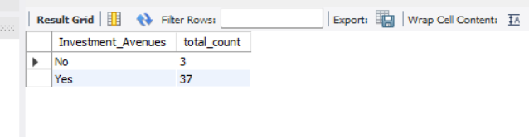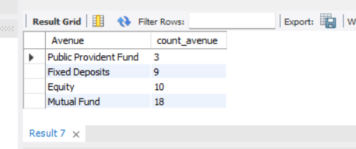
select Investment_Avenues,count(Investment_Avenues) as frequency from dataset group by Investment_Avenues order by frequency desc limit 1;
select Avenue,count(Avenue) as frequency from dataset group by Avenue order by frequency desc limit 1;
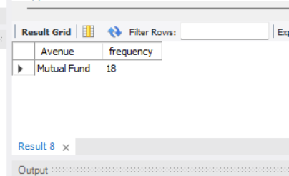
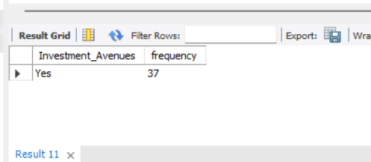
- Insight: i identified the most preferred investment option in avenue and investment_avunue finally I got avunue is 18 and investment_avunue is 37.

Level 3: Advanced
Task 5: Reasons for Investment
- Objective: Analyse reasons for investment choices
Details: to complete this task I used the UNION ALL command and using the group by and desc commands and I found the total count each resion like equety, bonds, fd ect and union that all at once, I have done the reasons for investment choices.
select Reason_Equity,Reason_Mutual,Reason_Bonds,Reason_FD from dataset;
select Reason_Equity,count(Reason_Equity) as total_Equity from dataset group by Reason_Equity order by total_Equity desc;
select Reason_Mutual,count(Reason_Mutual) as total_mutuval from dataset group by Reason_Mutual order by total_mutuval desc;
select Reason_Bonds,count(Reason_Bonds) as total_bonds from dataset group by Reason_Bonds order by total_bonds desc;
select Reason_FD,count(Reason_FD) as total_fd from dataset group by Reason_FD order by total_fd desc;
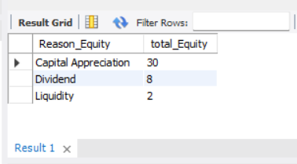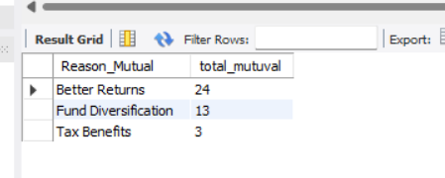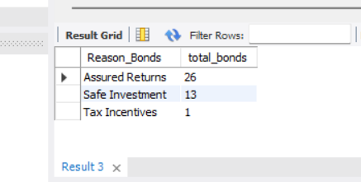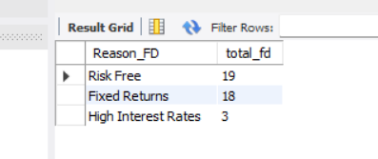
SELECT 'Equity' AS InvestmentName, Reason_Equity AS ReasonName, COUNT(Reason_Equity) AS total_frequency FROM dataset GROUP BY Reason_Equity
UNION ALL
SELECT 'Mutual Funds', Reason_Mutual, COUNT(Reason_Mutual) FROM dataset GROUP BY Reason_Mutual
UNION ALL
SELECT 'Bonds', Reason_Bonds, COUNT( Reason_Bonds) FROM dataset GROUP BY Reason_Bonds
UNION ALL
SELECT 'Fixed Deposits', Reason_FD, COUNT(Reason_FD) FROM dataset GROUP BY Reason_FD ORDER BY total_frequency DESC;
select Reason_Equity,Reason_Mutual,Reason_Bonds,Reason_FD from dataset;
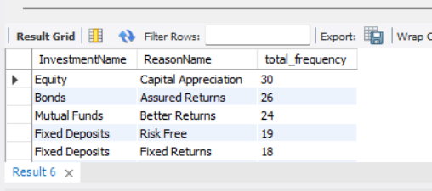
- Insight: People choose investments because they want higher returns, safety, and assured (fixed) returns.
Task 6: Savings Objectives
- Objective: Present main savings objectives
- Details: I have done this task why the participants are saving the objective what propose like health care, education, retirement etc. based given dataset set I took what are your saving objective column I count each one .
SELECT `What are your savings objectives?`, COUNT(`What are your savings objectives?`) AS total_frequency FROM dataset GROUP BY `What are your savings objectives?` ORDER BY total_frequency DESC;
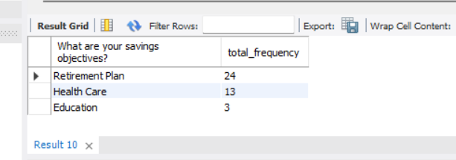
select `What are your savings objectives?`,count(`What are your savings objectives?`) as total_frequency from dataset
group by `What are your savings objectives?` order by total_frequency desc limit 1;
select `What are your savings objectives?`,count(`What are your savings objectives?`) as total_frequency from dataset
group by `What are your savings objectives?` order by total_frequency limit 1;
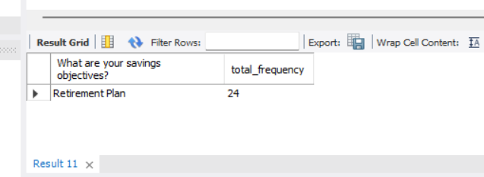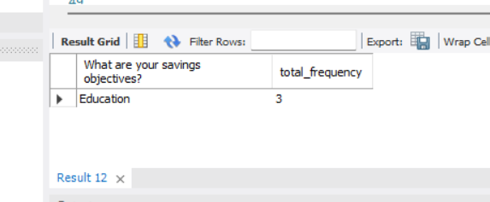
- Insight: after counting or writing the query I have known most participants are What are your savings objectives for retirement and second healthcare

Level 4: Expert
Task 7: Common Information Sources
- Objective: Analyse sources participants rely on
- Details: I have done in this task from where Participants investment are doing
Use the source column I have count each source
select source from dataset;
select source,count(source) as total_source from dataset group by source order by total_source;
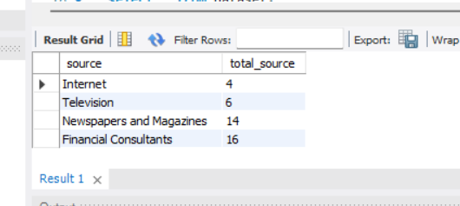
select source ,count(source) as total_source from dataset group by source order by total_source desc limit 1;
select source ,count(source) as total_source from dataset group by source order by total_source limit 2;
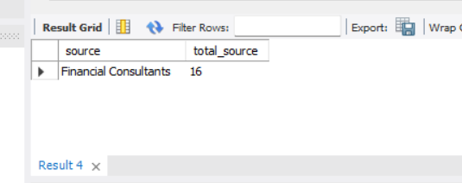
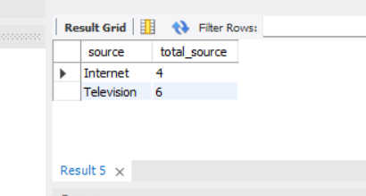
- Insight: I have found source, from where Participants is taking the investment Mostly the Participants is taking the investment from financial consultant and first, second is internet and telephone.
Task 8: Investment Duration
- Objective: Calculate average investment duration
- Details: I considered duration column in mutual dataset, in this how long the participants are doing the investments has. I analysied the dataset in MYSQL I calculated average investment. for this I used the average () function.
select duration from dataset;
select duration,count(duration) as total_count from dataset group by duration order by total_count;
select avg(duration) as avg_duration from dataset;
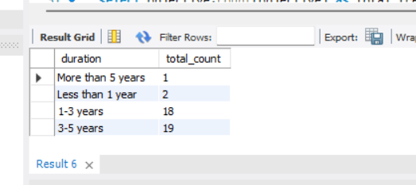

SELECT MIN(Duration) AS min_duration, MAX(Duration) AS max_duration, AVG(Duration) AS average_duration FROM dataset;
select Investment_Avenues, avg(duration) as avg_duration from dataset group by Investment_Avenues order by avg_duration desc;
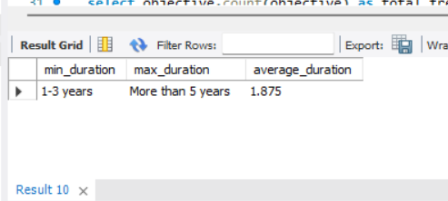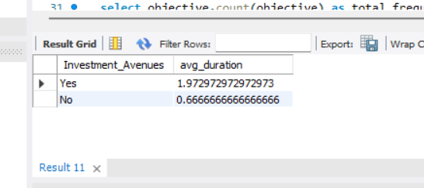
- Insight: Long-term investments were common among participants.
Task 9: Expectations from Investments
- Objective: Summarize participants' expectations
- Details: I analysied related columns like objective, purpose, no Expectations column is there. in these columns I found the what participants save given and I used the count and group by class.
select objective,count(objective) as total_frequency from dataset group by objective order by total_frequency desc;
select Purpose,count(Purpose) as total_frequency from dataset group by Purpose order by total_frequency desc;
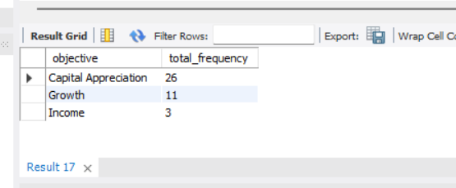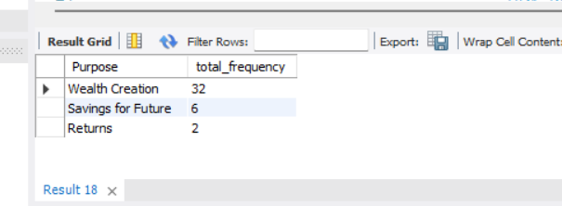
select objective,count(objective) as total_frequency from dataset group by objective order by total_frequency desc limit 1;
select objective,count(objective) as total_frequency from dataset group by objective order by total_frequency limit 1;
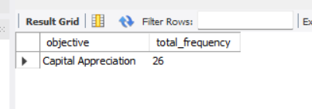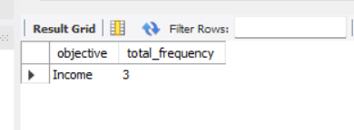
select Purpose,count(Purpose) as total_frequency from dataset group by Purpose order by total_frequency desc limit 1;
select Purpose,count(Purpose) as total_frequency from dataset group by Purpose order by total_frequency limit 1;
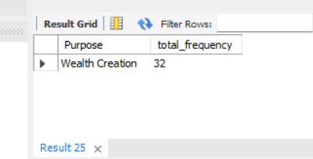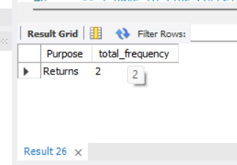
- Insight: Participants mostly expect capital appreciation and high returns. This indicates that they aim for wealth growth through their investments.
Task 10: Correlation Analysis
- Objective: Explore correlations between factors
- Details: in this task I selected numerical columns like age, mutuval_funds, duration, equity_ market ext. and I analysied relationship/ corelation ship between these columns. In MYSQL Corr() function do not have that’s why I calculated correlation using personal correlation formula.
SELECT
(COUNT(age)*SUM(age*Duration) - SUM(age)*SUM(Duration)) / SQRT((COUNT(age)*SUM(age*age) - SUM(age)*SUM(age)) *
(COUNT(age)*SUM(duration*Duration) - SUM(Duration)*SUM(Duration))) AS corr_age_duration
FROM dataset;
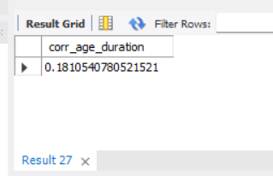
SELECT
(COUNT(age)*SUM(age*Mutual_Funds) - SUM(age)*SUM(Mutual_Funds)) / SQRT((COUNT(age)*SUM(age*age) - SUM(age)*SUM(age)) *
(COUNT(age)*SUM(Mutual_Funds*Mutual_Funds) - SUM(Mutual_Funds)*SUM(Mutual_Funds))) AS corr_age_Mutual_Funds
FROM dataset;
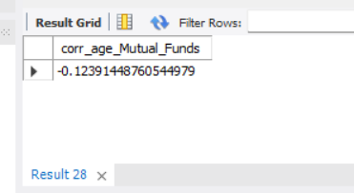
SELECT
(COUNT(duration)*SUM(duration*Mutual_Funds) - SUM(duration)*SUM(Mutual_Funds)) / SQRT((COUNT(duration)*SUM(duration*duration) - SUM(duration)*SUM(duration)) *
(COUNT(duration)*SUM(Mutual_Funds*Mutual_Funds) - SUM(Mutual_Funds)*SUM(Mutual_Funds))) AS corr_duration_Mutual_Funds
FROM dataset;
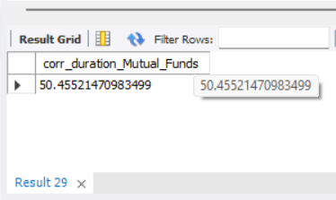
SELECT
(COUNT(Mutual_Funds)*SUM(Mutual_Funds*Equity_Market) - SUM(Mutual_Funds)*SUM(Equity_Market)) / SQRT((COUNT(Mutual_Funds)*SUM(Mutual_Funds * Mutual_Funds) - SUM(Mutual_Funds)*SUM(Mutual_Funds)) *
(COUNT(Mutual_Funds)*SUM(Equity_Market*Equity_Market) - SUM(Equity_Market)*SUM(Equity_Market))) AS corr_age_MF_EM
FROM dataset;
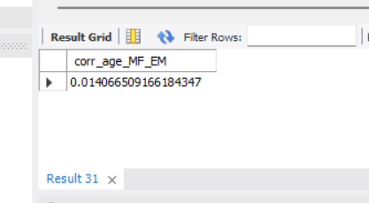
- Insight:
1. Older people tend to invest for longer periods.
2. between mutual funds and equity market have a relationship.
3. A positive correlation was observed between investment duration and mutual funds. This indicates that long-term investors tend to prefer mutual funds more

Visualization
- Gender Distribution
- Investment Preferences
- Savings Objectives
- Expectations from Investments

Key Insights
- Investors prefer high returns
- Safety is a major concern
- Long-term investments are common
- Mutual funds are widely preferred

Conclusion
The Mutual Funds dataset analysis provided valuable insights into investor behaviour, preferences, and financial goals. Analytical methods and visualizations helped extract meaningful patterns to assist in better investment decision-making.

References
- Cognifyz Technologies Dataset
- Business Analysis and Visualization Tools Documentation

Signature
Ragelagunta Venkatadri

